Hyun Suk Ryoo (Max Ryoo)

STAT 3220 HW5 Project Group (“Let’s Get this Piecewise Bread”)

9.2

A)

E(y) = B_0 + B_1(x_1) + B_2(x_1 - 1.45)x_2 + B_3(x_1 - 5.20)x_3

* x_2 and x_3 are dummy variables that are above the respective values of 1.45 and 5.20

B)

|  |  |  |  |
| --- | --- | --- | --- |
|  | $$x≤1.45$$ | $$1.45≤x≤5.20$$ | 5.20 < x |
| y-intercept | B_0 | B_0 – 1.45B_2 | B_0 – 1.45B_2 – 5.20B_3 |
| Slope | B_1 | B_0 + B_2 | B_0 + B_2 + B_3 |

C)

We would need to conduct a nested F-test like the ones we do for MLR. The null hypothesis will be that the betas are equal to 0 while the alternate is that at least one beta is not equal to zero.

9.4

A)

We can see an increasing trend, but around 70 for hours we can see a decreasing trend in the graph

B)

We can propose a piecewise model for the number of cells with the knot value of 70, which is where the slope seems to change in the scatter plot. It will follow the two straight lines discontinuous model shown on page 470

C)

E(y) = B_0 + B_1(x_1) + B_2(x_1 – 70) x_2 + B_3x_2

D)

Full Table Shown below

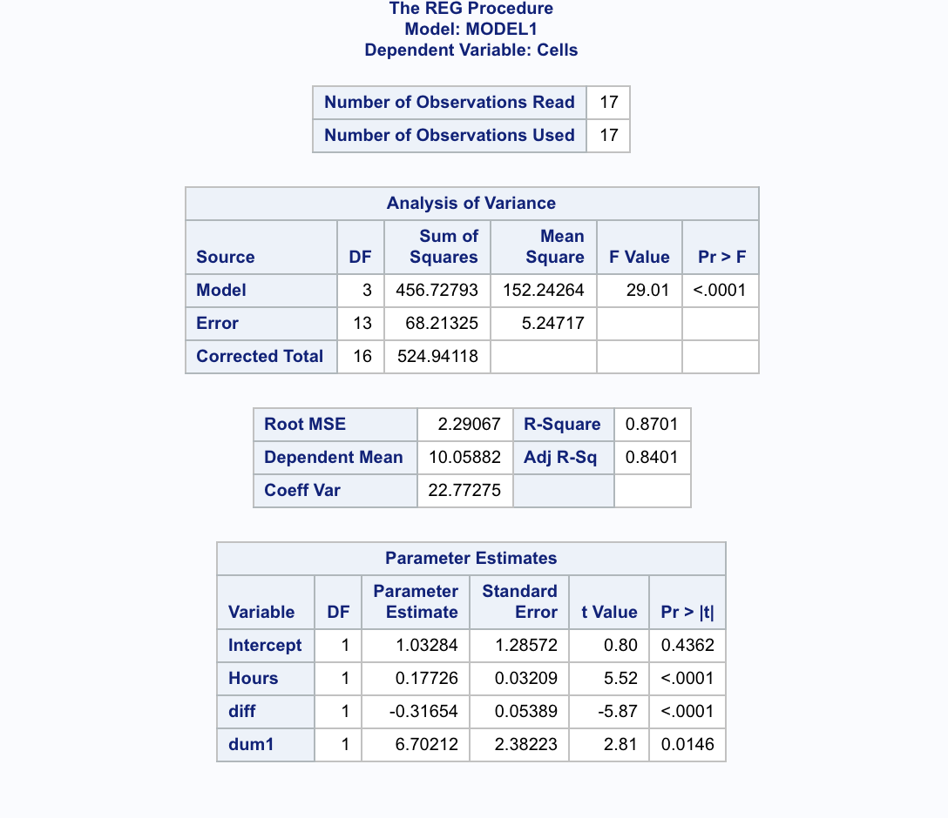

E)

For less than 70 hours will just be 0.17726 and for above it will be 0.177 - 0.31654 = -0.13955 = -0.14

F)

For this section we had to conduct a t test to see if the following hypotheses were held. For the first part the hypothesis will be …

Null: Beta = 0

Alternate: Beta1 != 0

For the second part the hypothesis will be

Null: Beta1 + Beta2 = 0

Alternate = Beta1 + beta2 !=0

Both t test statistics showed that we should reject the null hypothesis, which means that these tests were significant.